Pay bill User Guide documentation

1. QueryBillInfo

API gaan waxuu soo aqrinaaa bill ka ku taaagan ardayga

waxaaa loo dhiibaa ID-ga ardayga

1. Pay Bill Notification

API gaan waxuu qaadaa bill transaction dhanka EVC plus ka ama Bank

Transaction ka markuu ka dhaco dhanka EVC plus ka oo success soo celiyo dhankiina waxaa action u qaadaysiin ardayga

TESTING API’S

1. Hadaba si aad u tijaabiso labadaan daan API waxaa la soo degtaa POSTMAN
2. Kadibne fur POSTMAN ka soona import garayso file ka (HORMUUD PAYBILL.postman_collection.json)

Kujiro source code ka meesha aad ku dagisatay

**1 Request Query Bill Info**

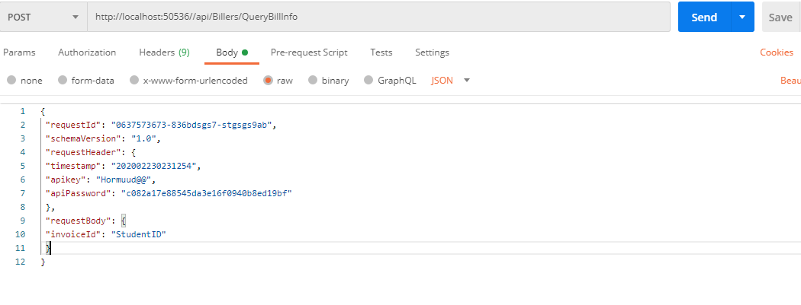

**2 Response Query Bill Info**

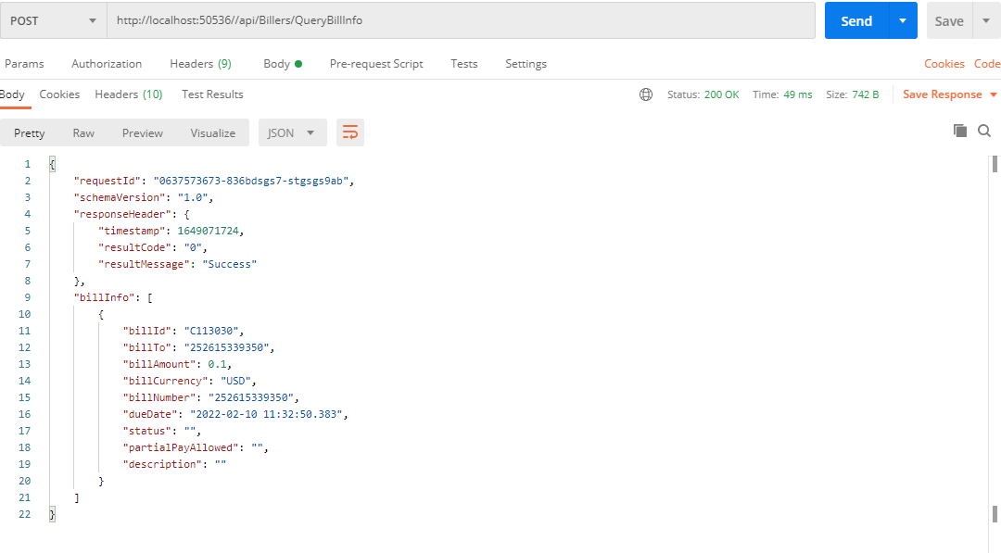

**3 Request Pay Bill Notification**

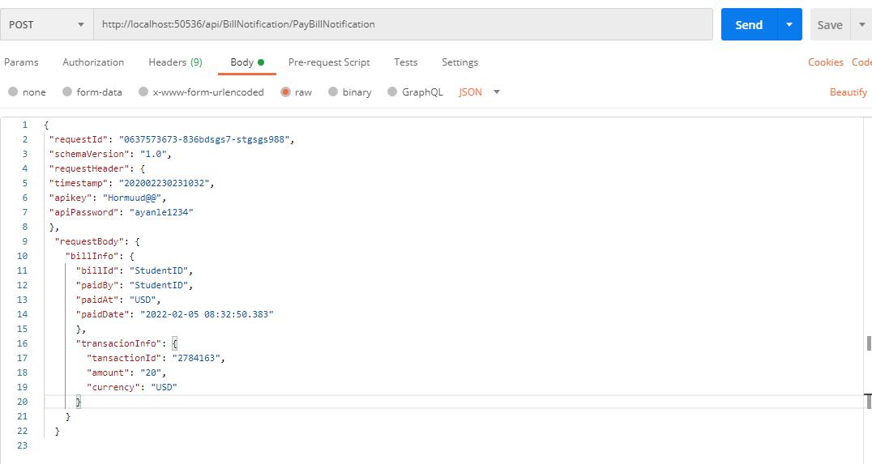

**4 Response Pay Bill Notification**

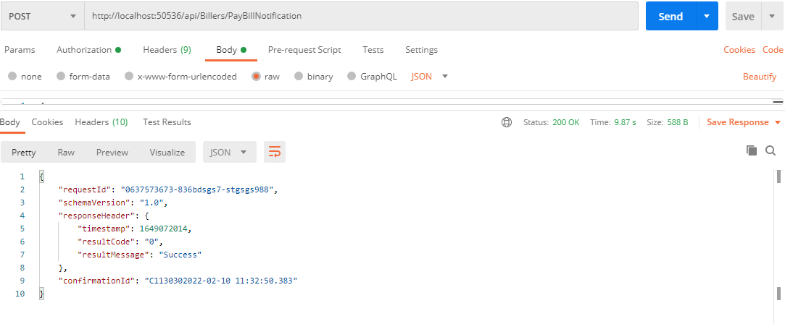

FG:

Inataas markaa tijaabisid waxaa nala wadaagtaa APIKEY iyo APIPassword ka

Si dhankeena aan uga tijaabino

Mahadsanid!